CS 346 - Telecommunications and Networks

**Lab 13 - Wireless & Shared Media - CSMA/CD, CSMA/CA, Wireless Channels, Frequencies and Widths, Rechanneling A WAP Tower Site**

Wireless signals are a “shared media”. Multiple devices utilize a shared wireless spectrum for multiple varied purposes. These purposes do not always align with each other. Media Access Control Protocols allow different devices with different purposes to collaboratively share the wireless spectrum.

We will learn about wireless channels, frequencies and channel widths and how these variables and related interference effect wifi signal strength. Then we will analyze a scenario where channel interference is causing connections issues.

**Prerequisites**

The ability to Read and Interpret a table of information. The understanding of how a map works. The ability to use a computer to type up and submit your answers.

**MAC Protocols**

CSMA/CD and CSMA/CA are two media access control protocols. Watch the following video and make sure you understand what these protocols are accomplishing:

<https://www.youtube.com/watch?v=iKn0GzF5-IU>

**Wireless Channels, Frequencies,**

Watch the following primer about Wireless Channels, Frequencies, and Channel Widths:

<https://www.youtube.com/watch?v=HHU2p_NfSx4>

**Rechanneling a Wireless Access Point (WAP) Tower Site**

Congratulations!

You now work in the Network Operations Center for a Wireless ISP. It’s Christmas and as the newest employee you are staffing NETOPS alone (as per tradition)!

Yay you!

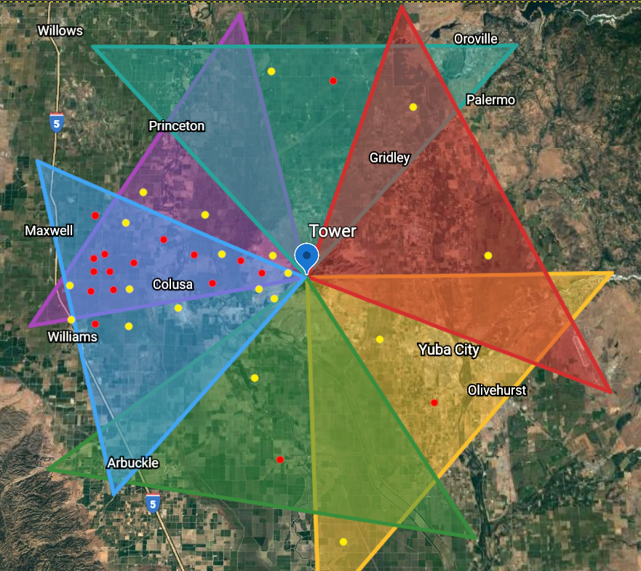

Within 5 minutes of the start of your shift the tech support team has fielded 30 support calls from customers. All of these customers are having connection issues. They are either completely offline (a red dot), or complaining of a slow connection (a yellow dot).

All of these ungrateful customers are connected to the same tower on the Sutter Buttes Mountain. This tower hosts 6 Wireless Access Points (WAP’s). Each of these WAPs broadcast a signal via a 90 degree sector antenna. The signal from each sector antenna is represented by a colored shape on the above map. The table below represents the channel configuration of the 6 WAP’s.

In this particular case we can analyze the map and can tell the majority of complaints are from customers in the area where the signal from WAP 3 and WAP 4 intersect. This points to a channel interference issue. If we look at the channel table we see that most of the WAP’s are currently set to a channel between 100 and 144. These are regulated channels known as DFS channels. In order to use DFS channels a WAP manufacturer must make sure the WAP is DFS compliant. A DFS compliant WAP must be able to automatically change channels at a moment's notice. In this case it looks like these WAP’s are out of whack because an automated DFS channel change.

In order to get these customers back online and cut down Tech Support’s call queue time (a major metric that your job performance is judged by) you’ll need to rechannel this tower site.

Do that now. Remember if you mess up and kick all 3,000 customers at this site offline you’ll probably get fired.

Now, go get those WAP’s out of whack before things really go wrong! Good luck and Merry Christmas (because that’s the day you are working in this realistic scenario)!

**Channel Tables**

**Current Channel Configuration**

|  |  |  |  |
| --- | --- | --- | --- |
| **Name** | **Map Color** | **Channel** | **Channel Width** |
| WAP 1 | Yellow | 102 | 40 MHz |
| WAP 2 | Green | 110 | 40 MHz |
| WAP 3 | Blue | 122 | 40MHz |
| WAP 4 | Purple | 126 | 40MHz |
| WAP 5 | Teal | 134 | 40MHz |
| WAP 6 | Red | 142 | 40MHz |

**Your Channel Configuration**

|  |  |  |  |
| --- | --- | --- | --- |
| **Name** | **Map Color** | **Channel** | **Channel Width** |
| WAP 1 | Yellow |  |  |
| WAP 2 | Green |  |  |
| WAP 3 | Blue |  |  |
| WAP 4 | Purple |  |  |
| WAP 5 | Teal |  |  |
| WAP 6 | Red |  |  |

**Reference Materials**

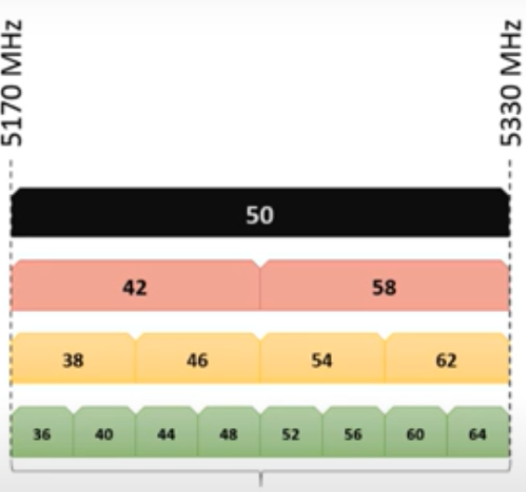

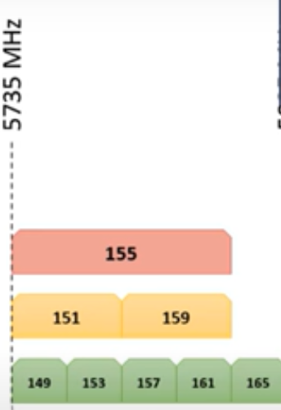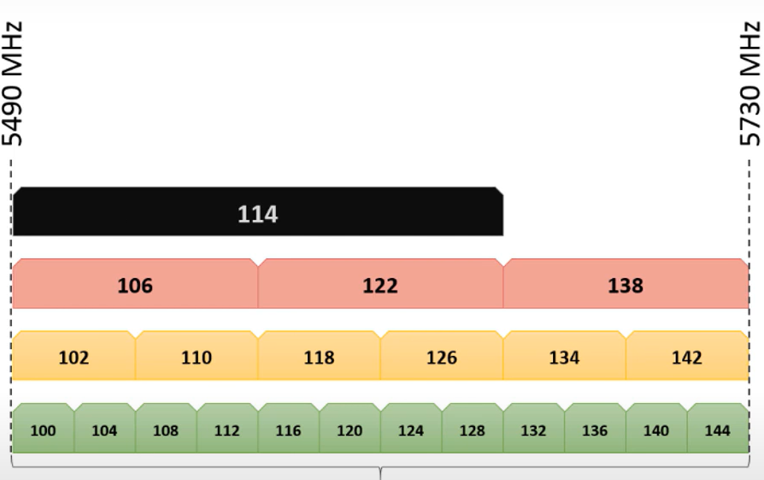

**Questions**

1. *What type of network is CSMA/CA used in?*
2. What type of signal does a CSMA/CD node send out when it notices a collision?
3. How long do the two nodes involved in a collision back-off before they attempt to resend their data?
4. Why is CSMA/CD much more pertinent in a network connected via HUBS vs a network connected via SWITCHES?
5. Which MAC protocol tries to avoid collisions?
6. *What is a wifi channel?*
7. Which of the following combinations do not interfere with each other:
   1. 5 and 9
   2. 10 and 4
   3. 1 and 6 and 10
8. How many non-overlapping 40MHz channels can be run in the 2.4Ghz band simultaneously?
9. How many non-overlapping 160Mhz channels can be run in the 5GHz band simultaneously (provided regulations allow all 5GHz 802.11 channels)?
10. How many non-overlapping 40Mhz channels can be run in the 5GHz band simultaneously?
11. What range of channels are considered DFS channels?
12. If a WAP is in range of a radar signal, what does it need to do to conform to DFS requirements?

**Deliverables:**

1. A reconfigured channel table where the channels are configured in such a way that gives the best possible connection to each possible customer.
2. The answers for the 12 listed questions.

**Please place these deliverables into a single document .pdf document and upload to LAB 13 on canvas**